

U23CS301- Problem Solving Using C

Project Report

Classroom Attendance Management System

Submitted By
CSE216- Sasikiran TT
CSE212- Sanjana B
CSE246- Surya P
CSE253- Tharunika SS

Problem statement
Classroom Attendance Management
Problem Statement: Classroom Attendance Management System Development in C
In educational institutions, managing student attendance is a crucial aspect of ensuring academic accountability and performance tracking. Traditional attendance tracking methods, such as manual registers or paper-based systems, are time-consuming, prone to errors, and lack real-time insights. These issues can result in data inaccuracies and difficulties in monitoring student participation over time. This highlights the need for an automated and reliable solution to streamline attendance management processes.
The proposed solution is to develop a Classroom Attendance Management System using the C programming language. This system will offer core functionalities such as student registration, marking attendance by date, tracking late arrivals, and generating reports for both monthly and yearly attendance. The system will use file handling to ensure data persistence, keeping student records and attendance logs secure and easily accessible.
The system will follow a modular design approach, making it easy to maintain, debug, and scale as needed. It will focus on providing a simple console-based interface, ensuring a user-friendly experience for educators and administrators. Additionally, it will incorporate data validation and error-handling mechanisms to prevent inconsistencies, such as marking attendance for future dates or exceeding class capacity.
By addressing these challenges, the Classroom Attendance Management System aims to improve attendance tracking accuracy, reduce administrative workload, and provide reliable reporting tools for educational institutions. This project seeks to bridge the gap between traditional attendance methods and modern digital solutions, ensuring a more efficient and transparent attendance management process.

Introduction
C programming Language
The C programming language, developed in the early 1970s by Dennis Ritchie at Bell Labs, is one of the most influential and widely used programming languages in the world. It serves as the foundation for many modern programming languages and remains an essential tool in system programming, embedded systems, and software development. Known for its efficiency and flexibility, C provides low-level access to memory, making it highly effective for performance-critical applications.
C is a procedural programming language that follows a structured approach to solving problems. It allows developers to write concise and efficient code using functions, data structures, and control flow mechanisms. Its simplicity and portability across different platforms have made it the preferred language for operating systems, compilers, and various embedded systems that require direct hardware interaction.
Despite its age, C continues to be a popular choice for both beginners and experienced programmers. Its ability to work with low-level operations, manage memory directly, and interact with hardware makes it invaluable in areas such as operating system design, game development, and real-time applications. Additionally, its influence can be seen in modern languages like C++, Java, and Python, all of which have drawn inspiration from C’s syntax and concepts.

Software Requirement

Category | Requirement
Development Tools | Code::Blocks, Dev-C++, Eclipse CDT, or Visual Studio Code
Compiler | GCC, MinGW, or Clang
Debugger | GDB (GNU Debugger)
Operating System | Windows 7 or later, Linux (Ubuntu/Fedora), macOS
Libraries | Standard C libraries: stdio.h, stdlib.h, string.h
Storage | Disk space for program files and data files
Memory | Minimum 4 GB RAM
Optional Tools | Git, GitHub/GitLab, Doxygen, Testing frameworks (Check, CUnit)

Design
Use case Diagram

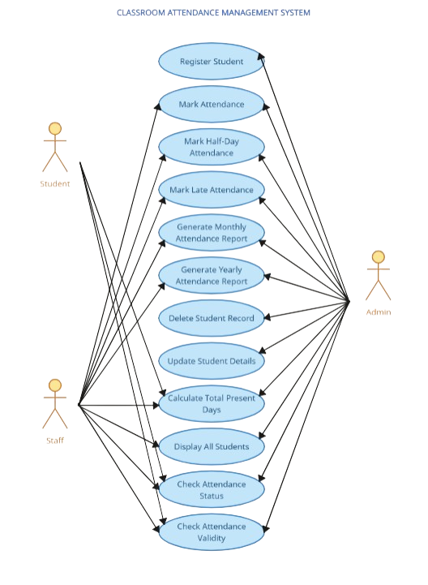
Fig : Use case diagram for classroom attendance management system
Design
Data Flow Diagram
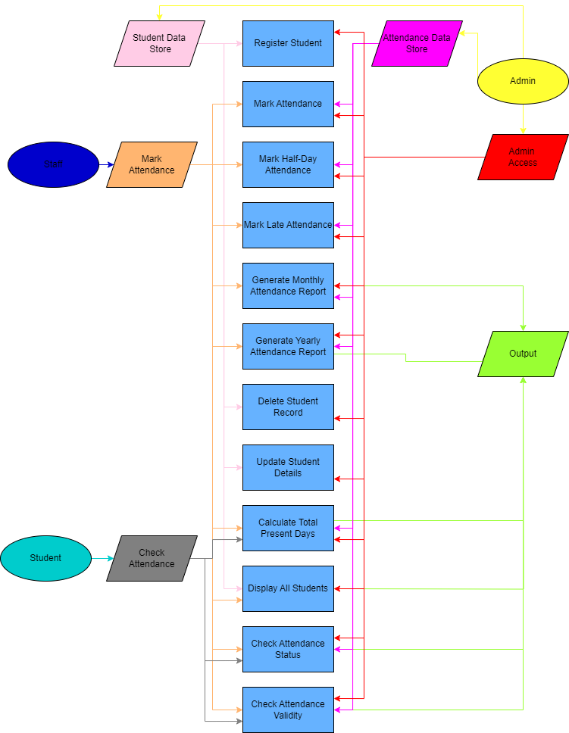
Fig : Data flow diagram for classroom attendance management system
Design
Flow Chart
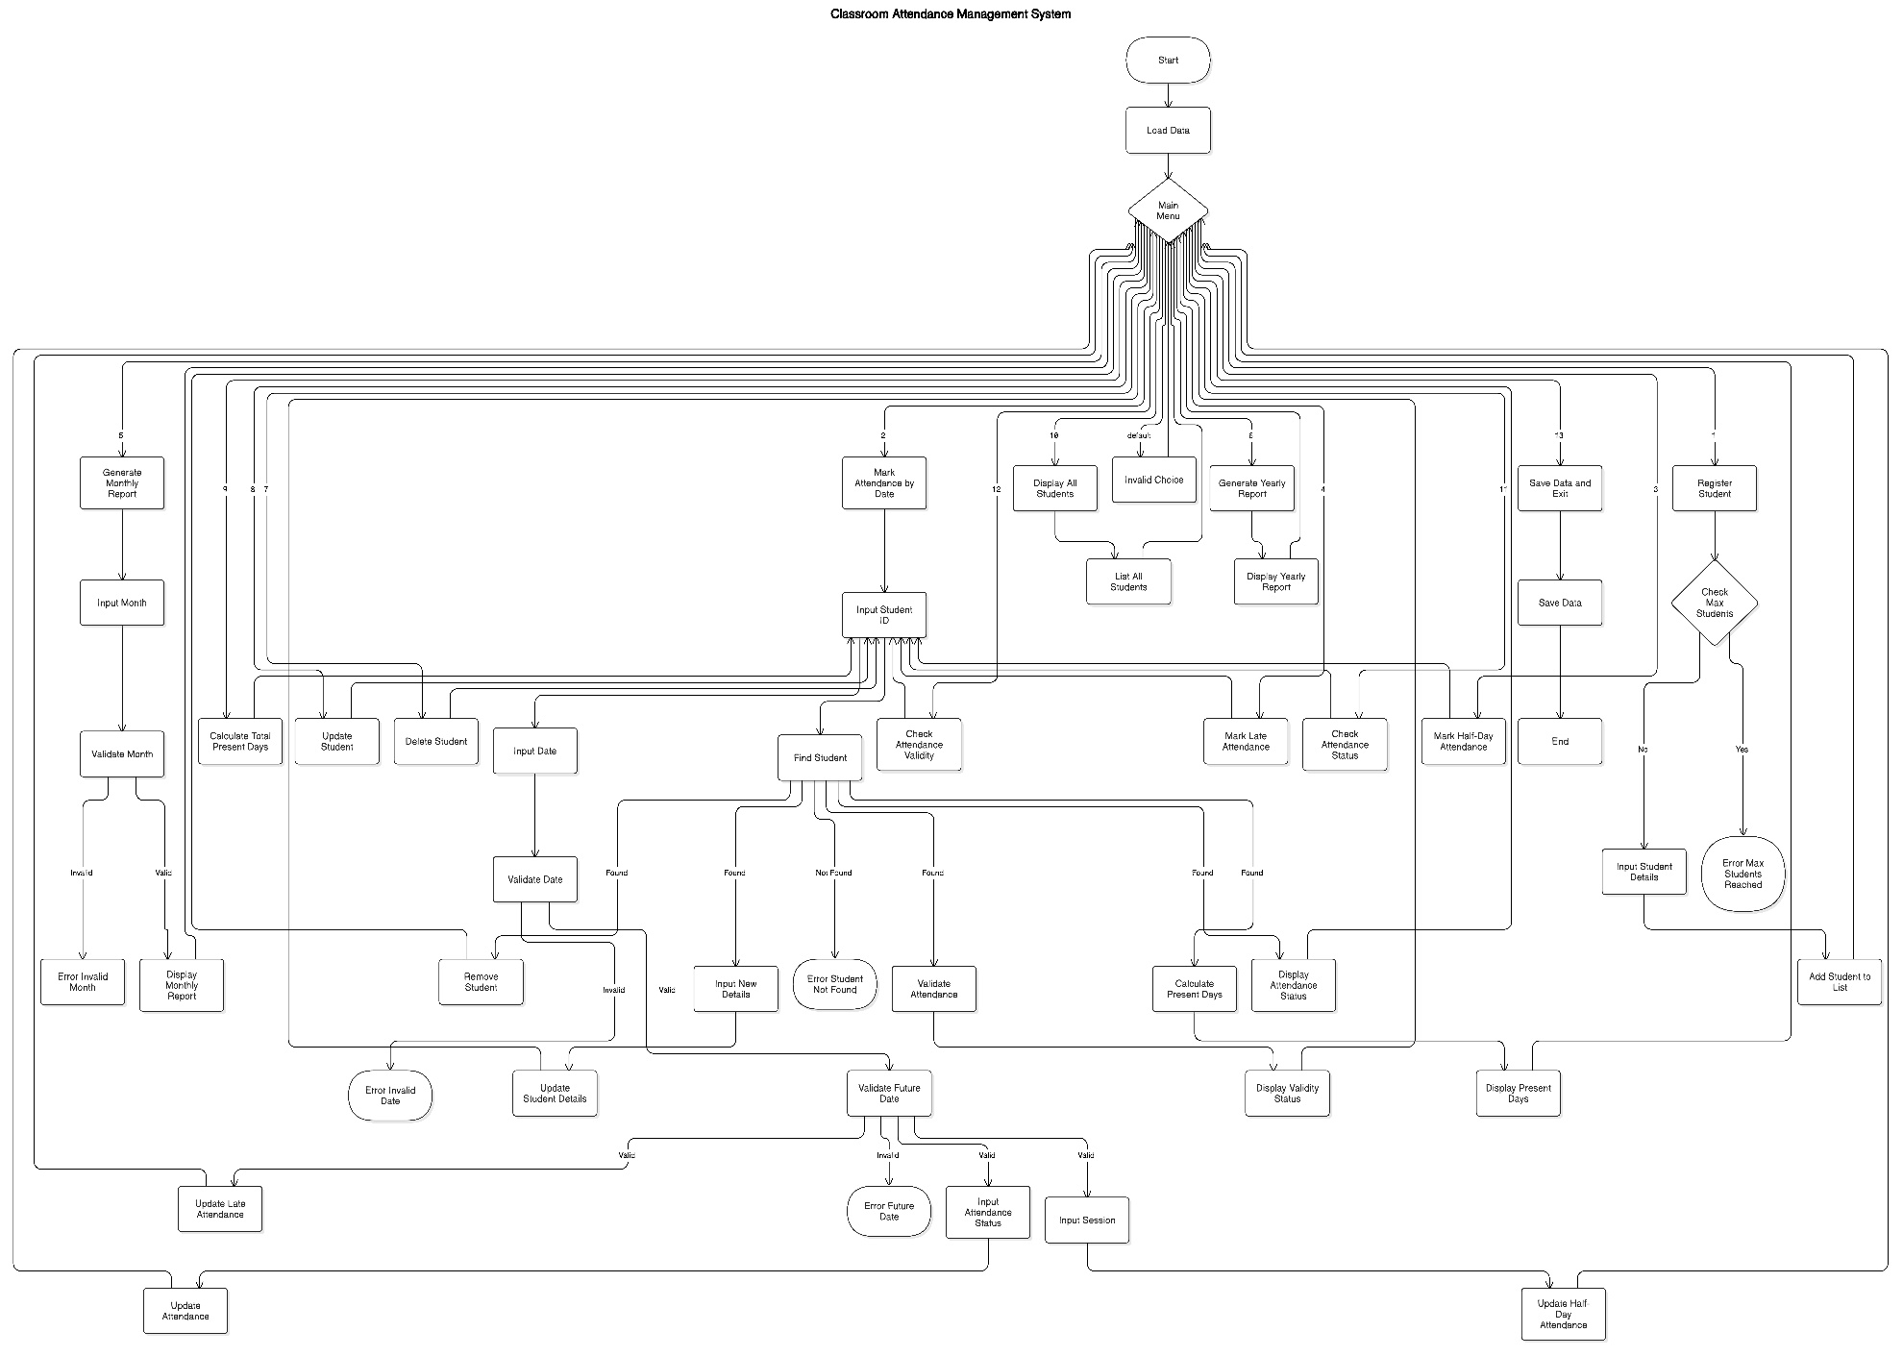
Fig : flow chart diagram for classroom attendance management system
Design
Pseudocode
Main Program
- Load Data: Load attendance data from a file.
- Main Menu: Repeatedly display options and execute the corresponding function until "Exit" is selected:
  - Register Student: Call register_student().
  - Mark Attendance by Date: Call mark_attendance_by_date().
  - Mark Half-Day Attendance: Call mark_half_day_attendance().
  - Mark Late Attendance: Call mark_late_attendance().
  - Generate Monthly Report: Call generate_monthly_report().
  - Generate Yearly Report: Call generate_yearly_report().
  - Delete Student: Call delete_student().
  - Update Student: Call update_student().
  - Calculate Total Present Days: Call calculate_total_present_days().
  - Display All Students: Call display_all_students().
  - Check Attendance Status: Call check_attendance_status().
  - Check Attendance Validity: Call check_attendance_validity().
  - Exit: Call save_data() and terminate.
Functions
- register_student()
  - Validate student count against MAX_STUDENTS.
  - Create a student record with ID, name, and 100% attendance.
  - Add to the list, increment count, and confirm registration.
- mark_attendance_by_date()
  - Validate student ID, date, and month.
  - Update attendance based on status:
    - Present (P): Increment present days.
    - Absent (A): Decrease attendance percentage by 2%.
- mark_half_day_attendance()
  - Validate student ID, date, and session (morning/afternoon).
  - Update attendance: Add 0.5 days and reduce percentage by 1%.
- mark_late_attendance()
  - Validate student ID and date.
  - Mark late attendance as 0.5 days and decrease percentage by 1%.
- generate_monthly_report()
  - Validate month and display total present days for each student.
- generate_yearly_report()
  - Display total yearly present days for all students.
- delete_student()
  - Find and remove a student by ID, then decrement count.
- update_student()
  - Find a student by ID, update details, and confirm changes.
- calculate_total_present_days()
  - Sum monthly present days for a student and display the total.
- display_all_students()
- List all students with their IDs and names.
- check_attendance_status()
- Display attendance percentage and status for a student by ID.
- check_attendance_validity()
- Check if attendance is below 75% for each student.
Data Management
- save_data()
  - Write student count and details (ID, name, percentage, monthly data) to a file.
- load_data()
  - Read student count and details from a file into the system.
Module
The Classroom Attendance Management System is designed with several core modules to ensure organized and efficient functionality. The Student Management Module handles student registration and maintains details such as roll number, name, and attendance records. The Attendance Management Module facilitates marking, updating, and viewing attendance for individual students on specific days. The Report Generation Module allows the generation of detailed attendance reports for students over a 30-day period. Lastly, the Data Management Module ensures secure and persistent storage of all student and attendance data through file-based storage mechanisms.
Module Details Description:
- Student Management Module
  - Purpose: Responsible for registering new students, maintaining their basic details such as roll number and name, and initializing their attendance records.
Functions:
  - registerStudent(): Registers a new student by recording their roll number and name and initializing their attendance records to default values (typically marking them as absent for all days initially).
  - deleteStudent(): Removes a student's details from the system based on their roll number, ensuring that the data is no longer available.
  - updateStudent(): Updates a student's details, such as name, contact information, or other relevant data.
- Attendance Management Module
  - Purpose: Manages the attendance marking process for students on specific dates, allowing for modifications and tracking of attendance statuses.
Functions:
  - markAttendanceDate(): Records attendance (present or absent) for a specific student on a given day.
  - markHalfDayAttendance(): Marks a student as present for only half of the day.
  - markLateAttendance(): Marks a student as late for a particular day.
  - viewAttendance(): Displays a student's attendance for all 30 days, showing which days they were present, absent, late, or marked for half-day attendance.
  - checkAttendanceStatus(): Checks the attendance status (present, absent, late, or half-day) for a specific student on a given date.
- Report Generation Module
  - Purpose: Provides detailed reports based on attendance data, useful for generating monthly or yearly summaries of student attendance.
Functions:
  - generateMonthlyReport(): Generates a report of a student's attendance for the current month, indicating their attendance status (present, absent, late, or half-day) for each day.
  - generateYearlyReport(): Generates a comprehensive report of a student's attendance over the entire year, summarizing their attendance status each month.
- Data Management Module
  - Purpose: Ensures data integrity by providing functionality to save and load student and attendance records. It also validates user input to prevent errors.
Functions:
  - saveData(): Saves all student and attendance data to a file, ensuring persistence across system restarts.
  - loadData(): Loads saved data from a file during the program's startup, restoring the system’s state to ensure continuity.
  - validateInput(): Ensures user inputs, such as roll numbers and attendance entries, are valid, preventing invalid or out-of-range data from being entered.
  - validateDate(int month, int date): Validates a given date (month and day) to ensure it falls within acceptable limits (e.g., valid calendar date).
  - validateFutureDate(int month, int date): Ensures that the provided date is not in the future and is a valid date for attendance marking.
Functions by Module:\
• Student Management Functions:
- registerStudent(): Registers a new student, recording their roll number, name, and initializing attendance.
- deleteStudent(): Deletes a student's record and attendance data.
- updateStudent(): Updates a student's details, such as personal or contact information.
• Attendance Management Functions:
- markAttendanceDate(): Marks attendance for a student on a specific day.
- markHalfDayAttendance(): Marks a student as present for half a day.
- markLateAttendance(): Marks a student as late on a given day.
- viewAttendance(): Displays a student’s full attendance record for 30 days.
- checkAttendanceStatus(): Checks a student’s attendance status on a particular day.
• Report Generation Functions:
- generateMonthlyReport(): Generates a detailed monthly attendance report for a student.
- generateYearlyReport(): Generates a detailed yearly attendance report for a student.
• Data Management Functions:
- saveData(): Saves student and attendance data to a file for persistence.
- loadData(): Loads saved data from a file to restore the system’s state.
- validateInput(): Validates user input for correctness.
- validateDate(): Validates the provided date (month and day).
- validateFutureDate(): Ensures the given date is not in the future for attendance marking

Implementation
#include <stdio.h>
#include <stdlib.h>
#include <string.h>
#include <time.h>
// Struct for student information
typedef struct {
int id;
char name[50];
float attendance_percentage;
float total_present_days;
float monthly_present_days[12];
float daily_present_days[12][31];
int late_days[12][31];
} Student;
// Constants
#define MAX_STUDENTS 100
#define DATA_FILE "attendance_data.txt"
// Global variables
Student students[MAX_STUDENTS];
int student_count = 0;
// Function declarations
void save_data();
void load_data();
void register_student();
void mark_attendance_date();
void mark_half_day_attendance();
void mark_late_attendance();
void generate_monthly_report();
void generate_yearly_report();
void delete_student();
void update_student();
void calculate_total_present_days();
void display_all_students();
void check_attendance_status();
void validate_date(int month, int date);
void validate_future_date(int month, int date);
void check_attendance_validity();
int main() {
load_data();
int choice;
do {
printf("\n=========================================");
printf("\n CLASSROOM ATTENDANCE MANAGEMENT SYSTEM ");
printf("\n=========================================\n");
printf("\n[1] Register Student");
printf("\n[2] Mark Attendance by Date");
printf("\n[3] Mark Half-Day Attendance (Morning/Afternoon)");
printf("\n[4] Mark Late Attendance");
printf("\n[5] Generate Monthly Attendance Report");
printf("\n[6] Generate Yearly Attendance Report");
printf("\n[7] Delete Student Record");
printf("\n[8] Update Student Details");
printf("\n[9] Calculate Total Present Days");
printf("\n[10] Display All Students");
printf("\n[11] Check Attendance Status");
printf("\n[12] Check Attendance Validity");
printf("\n[13] Exit\n");
printf("\nEnter your choice: ");
scanf("%d", &choice);
switch (choice) {
case 1:register_student();break;
case 2:mark_attendance_date();break;
case 3:mark_half_day_attendance();break;
case 4:mark_late_attendance();break;
case 5:generate_monthly_report();break;
case 6:generate_yearly_report();break;
case 7:delete_student();break;
case 8:update_student();break;
case 9:calculate_total_present_days();break;
case 10:display_all_students();break;
case 11:check_attendance_status();break;
case 12:check_attendance_validity();break;
case 13:save_data();printf("Data saved. Exiting program.\n");break;
default:printf("Invalid choice. Please try again.\n");
}
} while (choice != 13);
return 0;
}
// Function to validate month and date input
void validate_date(int month, int date) {
if (month < 1 || month > 12 || date < 1 || date > 31) {
printf("Invalid month or date. Please try again.\n");
exit(1);
}
}
// Function to validate future date
void validate_future_date(int month, int date) {
time_t t;
struct tm *current_time;
time(&t);
current_time = localtime(&t);
int current_month = current_time->tm_mon + 1;
int current_day = current_time->tm_mday;
if (month > current_month || (month == current_month && date > current_day)) {
printf("Error: Cannot mark attendance for a future date!\n");
exit(1);
}
}
// Function to save data to file
void save_data() {
FILE *file = fopen(DATA_FILE, "w");
if (!file) {
printf("Error: Unable to save data.\n");
return;
}
fprintf(file, "%d\n", student_count);
for (int i = 0; i < student_count; i++) {
fprintf(file, "%d %s %.2f %.2f\n",
students[i].id, students[i].name, students[i].attendance_percentage,
students[i].total_present_days);
for (int j = 0; j < 12; j++) {
fprintf(file, "%.2f ", students[i].monthly_present_days[j]);
}
fprintf(file, "\n");
}
fclose(file);
}
// Function to load data from file
void load_data() {
FILE *file = fopen(DATA_FILE, "r");
if (!file) {
printf("No existing data found. Starting fresh.\n");
return;
}
fscanf(file, "%d", &student_count);
for (int i = 0; i < student_count; i++) {
fscanf(file, "%d %s %f %f",
&students[i].id, students[i].name, &students[i].attendance_percentage,
&students[i].total_present_days);
for (int j = 0; j < 12; j++) {
fscanf(file, "%f", &students[i].monthly_present_days[j]);
}
}

fclose(file);
}
// Function to register a new student
void register_student() {
if (student_count >= MAX_STUDENTS) {
printf("Error: Cannot add more students.\n");
return;
}
Student new_student;
printf("Enter Student ID: ");
scanf("%d", &new_student.id);
printf("Enter Student Name: ");
scanf("%49s", new_student.name);
new_student.attendance_percentage = 100.0;
new_student.total_present_days = 0;
memset(new_student.monthly_present_days, 0, sizeof(new_student.monthly_present_days));
students[student_count++] = new_student;
printf("Student registered successfully.\n");
}
// Function to mark attendance by date
void mark_attendance_date() {
int id, month, date;
char status[10];
printf("Enter Student ID: ");
scanf("%d", &id);
printf("Enter Month (1-12): ");
scanf("%d", &month);
printf("Enter Date (1-31): ");
scanf("%d", &date);
validate_date(month, date);
validate_future_date(month, date);
printf("Enter Attendance Status (Present[P]/Absent[A]): ");
scanf("%s", status);
for (int i = 0; i < student_count; i++) {
if (students[i].id == id) {
students[i].total_present_days++;
if (strcmp(status, "P") == 0 || strcmp(status, "p") == 0 ) {
students[i].monthly_present_days[month - 1]++;
} else if (strcmp(status, "A") == 0 || strcmp(status, "a") == 0) {
students[i].attendance_percentage -= 2.0;
if (students[i].attendance_percentage < 0) {
students[i].attendance_percentage = 0;
}
} else {
printf("Invalid status. Use 'Present[P]' or 'Absent[A]'.\n");
return;
}
printf("Attendance updated for %d/%d.\n", date, month);
return;
}
}
printf("Error: Student not found.\n");
}
// Function to mark late attendance
void mark_late_attendance() {
int id, month, date;
printf("Enter Student ID: ");
scanf("%d", &id);
printf("Enter Month (1-12): ");
scanf("%d", &month);
printf("Enter Date (1-31): ");
scanf("%d", &date);
validate_date(month, date);
validate_future_date(month, date);
for (int i = 0; i < student_count; i++) {
if (students[i].id == id) {
if (students[i].daily_present_days[month - 1][date - 1] == 1) {
printf("Student is already marked as present for this day.\n");
return;
}
students[i].daily_present_days[month - 1][date - 1] = 0.5;
students[i].monthly_present_days[month - 1] += 0.5;
students[i].total_present_days += 0.5;
students[i].late_days[month - 1][date - 1] = 1;
students[i].attendance_percentage -= 1.0;
if (students[i].attendance_percentage < 0) {
students[i].attendance_percentage = 0;
}
printf("Late attendance marked for %d/%d.\n", date, month);
return;
}
}
printf("Error: Student not found.\n");
}
// Function to mark half-day attendance
void mark_half_day_attendance() {
int id, month, date;
char session[10];
printf("Enter Student ID: ");
scanf("%d", &id);
printf("Enter Month (1-12): ");
scanf("%d", &month);
printf("Enter Date (1-31): ");
scanf("%d", &date);
validate_date(month, date);
validate_future_date(month, date);
printf("Enter Session (Morning[M]/Afternoon[A]): ");
scanf("%s", session);
for (int i = 0; i < student_count; i++) {
if (students[i].id == id) {
if (strcmp(session, "M") == 0 || strcmp(session, "A") == 0 || strcmp(session, "m") == 0 || strcmp(session, "a") == 0) {
students[i].daily_present_days[month - 1][date - 1] += 0.5;
students[i].monthly_present_days[month - 1] += 0.5;
students[i].total_present_days += 0.5;
students[i].attendance_percentage -= 1.0;
if (students[i].attendance_percentage < 0) {
students[i].attendance_percentage = 0;
}
printf("Half-day attendance marked successfully for %s session on %d/%d.\n", session, date, month);
} else {
printf("Invalid session. Use 'morning' or 'afternoon'.\n");
}
return;
}
}
printf("Error: Student not found.\n");
}
// Function to generate monthly attendance report
void generate_monthly_report() {
int month;
printf("Enter Month (1-12): ");
scanf("%d", &month);
validate_date(month, 1);
printf("Monthly Attendance Report for Month %d:\n", month);
for (int i = 0; i < student_count; i++) {
printf("ID: %d, Name: %s, Present Days: %.2f\n", students[i].id, students[i].name, students[i].monthly_present_days[month - 1]);
}
}
// Function to generate yearly attendance report
void generate_yearly_report() {
printf("Yearly Attendance Report:\n");
for (int i = 0; i < student_count; i++) {
printf("ID: %d, Name: %s, Total Present Days: %.2f\n", students[i].id, students[i].name, students[i].total_present_days);
}
}
// Function to delete a student
void delete_student() {
int id;
printf("Enter Student ID to delete: ");
scanf("%d", &id);
for (int i = 0; i < student_count; i++) {
if (students[i].id == id) {
for (int j = i; j < student_count - 1; j++) {
students[j] = students[j + 1];
}
student_count--;
printf("Student deleted successfully.\n");
return;
}
}
printf("Error: Student not found.\n");
}
// Function to update student details
void update_student() {
int id;
printf("Enter Student ID to update: ");
scanf("%d", &id);
for (int i = 0; i < student_count; i++) {
if (students[i].id == id) {
printf("Enter new name: ");
scanf("%49s", students[i].name);
printf("Student details updated.\n");
return;
}
}
printf("Error: Student not found.\n");
}
// Function to calculate total present days for individual students
void calculate_total_present_days() {
char choice;
do {
int student_id;
printf("Enter Student ID to calculate total present days: ");
scanf("%d", &student_id);
int found = 0;
for (int i = 0; i < student_count; i++) {
if (students[i].id == student_id) {
found = 1;
students[i].total_present_days = 0;
for (int j = 0; j < 12; j++) {
students[i].total_present_days += students[i].monthly_present_days[j];
}
printf("Total Present Days for %s: %.2f\n", students[i].name, students[i].total_present_days);
break;
}
}
if (!found) {
printf("Student ID %d not found.\n", student_id);
}
printf("\nDo you want to check another student? (y/n): ");
scanf(" %c", &choice);
} while (choice == 'y' || choice == 'Y');
printf("Total present days calculation complete.\n");
}
// Function to display all students
void display_all_students() {
printf("Displaying all students:\n");
for (int i = 0; i < student_count; i++) {
printf("ID: %d, Name: %s\n", students[i].id, students[i].name);
}
}
// Function to check attendance status of a student
void check_attendance_status() {
int id;
printf("Enter Student ID: ");
scanf("%d", &id);
for (int i = 0; i < student_count; i++) {
if (students[i].id == id) {
printf("Attendance Status for %s (ID: %d):\n", students[i].name, id);
printf("Attendance Percentage: %.2f%%\n", students[i].attendance_percentage);
return;
}
}
printf("Error: Student not found.\n");
}
// Function to check attendance validity for individual students
void check_attendance_validity() {
printf("Checking attendance validity...\n");
char choice;
do {
int student_id;
printf("Enter Student ID to check: ");
scanf("%d", &student_id);
int found = 0;
for (int i = 0; i < student_count; i++) {
if (students[i].id == student_id) {
found = 1;
if (students[i].attendance_percentage < 75) {
printf("Student ID: %d, Name: %s - Low Attendance (%.2f%%)\n", students[i].id, students[i].name, students[i].attendance_percentage);
} else {
printf("Student ID: %d, Name: %s - Perfect Attendance (%.2f%%)\n", students[i].id, students[i].name, students[i].attendance_percentage);
}
}
}
if (!found) {
printf("Student ID %d not found.\n", student_id);
}
printf("\nDo you want to check another student? (y/n): ");
scanf(" %c", &choice);
} while (choice == 'y' || choice == 'Y');
printf("Attendance validity check complete.\n");
}

Output

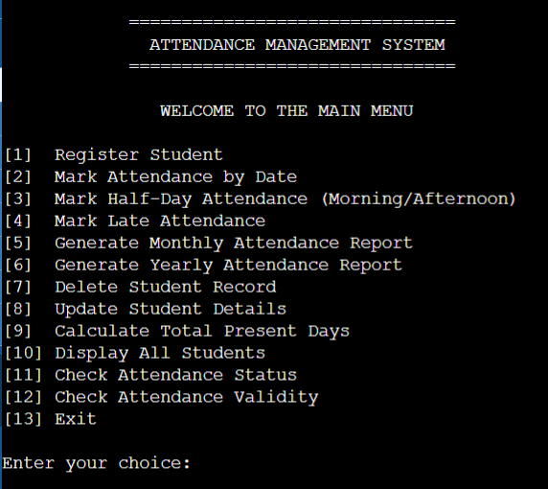
Fig : Main menu

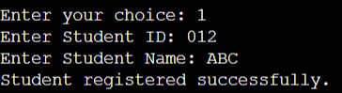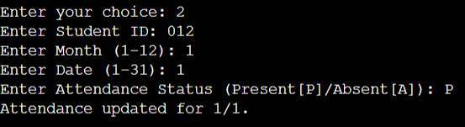
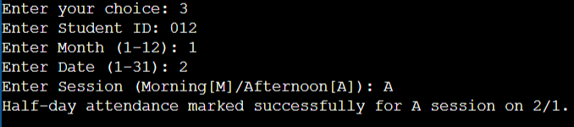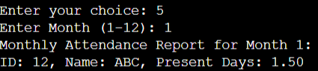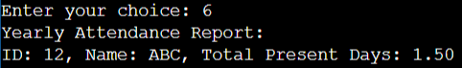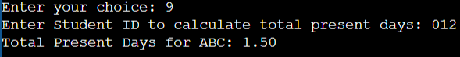
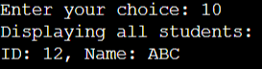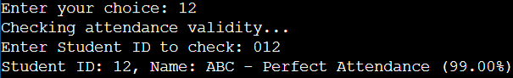

Fig : Mark Attendance

Conclusion
The Classroom Attendance Management System implemented in C showcases the practical application of fundamental programming concepts to address real-world educational needs in an efficient and organized manner. By employing modular design, file handling, and interactive user interfaces, the system successfully facilitates essential functionalities such as student registration, attendance marking, and report generation, while ensuring data persistence.
This project serves as a reliable foundation for further enhancements, such as integrating advanced features like automated reminders, more detailed reporting capabilities, and incorporating security measures for sensitive student data. With its straightforward, console-based interface, the system provides a valuable learning tool for students, as well as a potential solution for managing attendance in small to medium-scale classroom environments.
Through this development, the project demonstrates the versatility of C programming in constructing structured, efficient, and maintainable software systems, providing an excellent prototype for classroom attendance management.

